Real-time Sports Fitness Monitoring System for Athlete’s based on Internet of Things

Md. Arif Fuad Akash1, Md. Mizanur Rahman2, Morium Begum3

Department of Computer Science and Engineering (University of Liberal Arts Bangladesh, Bangladesh)

arif.fuad.cse@ulab.edu.bd, mizanur.rahman.1cse@ulab.edu.bd, morium.begum.cse@ulab.edu.bd

*Abstract-* **Monitoring of the fitness of Athletes is getting more and more important in every sector of sports nowadays because athletes must be fit before their sports event. As the progress of the Internet of Things (IoT) is developing unexpectedly, it is contributing significantly in this sector of sports. It is very necessary to measure the fitness level of the players and also very important for every organization all over the world. In our paper, we propose a Real-time Sports Fitness Monitoring System for Athlete’s based on Internet of Things particularly on heartbeat, a system from which the condition of athletes can be categorized the level of sports people’s fitness so that the organizations can understand the real condition of their athletes.**

**Keywords- IoT, Fitness Monitoring, PSO, RFID, Heart rate monitoring, bpm**

**I.** INTRODUCTION

Physical fitness is very important for everyone in the world. It is very necessary for sports persons also. The monitoring system of fitness can reduce the possibility of risks and injuries of the sports persons. If the athletes maintain the protocol of proper fitness, they remain fit before the sports event. Otherwise there are huge chances of falling in injuries sometimes. The Internet of Things has brought a great change in sports sectors by offering some measuring algorithms like Particle Swarm Optimization (PSO), cluster routing algorithm [1]. As we are living in the Internet age, there are many possibilities to do different types of research regarding any matter. Fitness monitoring system is one of them. Many technologies such as Radio Frequency Identification (RFID) tag, heart rate sensors, cloud computing support, smart phone as well as different modern tools are used in IoT. Some researchers said that about 25 billion IoT devices would be installed by 2020 and the IoT market would reach around 2.1 trillion by 2025 which would be a great achievement of IoT. It is very possible to monitor the fitness test by using these huge numbers of IoT devices [2]. Not only in medicals and hospitals but also in the personal health care and facilities are being enhanced by the IoT technology nowadays and biochemical biochemical is one of the recent trending examples to provide better health care and monitoring fitness [3]. Sometimes fitness can be tracked using multiple wearable sensors [4]. There is little known about how HR monitoring influences the perception of exertion and attention allocation[5]. By enabling athletes to track and modify their fitness exercises, technology has completely changed the fitness sectors. With the use of wireless sensor network technology, the Internet of Things (IoT), a symbol of contemporary technology, has entered people's daily lives. The use of sensors and technology to assist people during physical activity is increasing. These devices include basic sensors, tiny fitness bands, basic electronic scales, and cutting-edge sleep monitors [6]. IoT devices are used in many industries to make users' daily lives easier. These useful tools are used to collect data such as temperature, pressure, sugar level, and others that are used to assess the patient's fitness. Heart rate abnormalities are directly recognizable and communicated to each patient and athlete advisor via the internet and devices. The patient's whole medical history is then documented and made online accessible [7]. One of the researchers has shown different types of calculation based on heart rate for keeping the body fit. The technology now allows us to post parameters (heartbeats) online. There is still room for development, though. Waist circumference, BMI (body mass index), blood pressure, and blood sugar levels are a few other variables that can be assessed. The athlete's whole medical history is then documented and made online accessible [8]. Measurement results will be obtained using our developed system in this monitoring system. Real-life measurement and implementation of the system will be carried out [9].

**II.** RELATED WORK

The use of heart rate (HR) and heart rate variability (HRV) measures in sports have been discussed for decades, as they represent an inexpensive, time-efficient, and non-invasive method to monitor the status of the autonomic nervous system (ANS) and cardiovascular fitness[10]. The heart of the athlete has intrigued clinicians and scientists for more than a century. Early investigations in the late 1800s and early 1900s documented cardiac enlargement and bradyarrhythmias in individuals with above-normal exercise capacity and no attendant signs of cardiovascular disease [11]. Generally the heart rate of athletes is lower than others that is measured in beats per minute (bpm) but the heart rate is best measured when the athlete is sitting or lying down, and s/he in a calm state. Typically the normal resting pulse is somewhere in the range of 60% and 80% of general individuals by beats per minute (bpm) yet a few competitors have resting heart rates however low as 30 to 40 bpm which seems to be a recognizable issue. The resting heart rates vary from person to person including athletes. Some factors would be influenced including age, fitness level, amount of physical activity, body size, body position, air temperature based on hot or humid days, heart rate may increase of current time, emotions like stress, anxiety, and excitement can increase heart rate, medication like beta blockers can slow heart rate, while some thyroid medications can increase it and so on. Experiencing chest pain, irregular heartbeat rate and fainting during exercise are some abnormal syndrome of the heart. Most athletes train at between 50% and 70% of their maximum heart rate. For example, if an athlete's maximum heart rate is 180 beats per minute (bpm), the target-training zone would be between 90 and 126 bpm. Using a heart rate monitor to keep track during exercise is a must for every athlete. Gabriele Mascherini and her mates said the heart rate varies from person to person and particularly child, young and aged people. A study carried out on 7896 youthful competitors (5356 guys and 2540 females) matured somewhere in the range of 10 and 18 who went through pre-support evaluation to get qualification for cutthroat game. In the first place, anthropometric boundaries, execution information, and HR are accounted for. Consequently, each age determined third, 10th, twenty-fifth, 50th, seventy-fifth, 90th, and ninety-seventh percentiles for the stage-by-stage HR reaction, as indicated by sex and evaluated practice test methodology class. Youthful female competitors of any age showed lower execution with less stages performed on the cycle ergometer and the treadmill. Youthful male competitors on treadmill and cycle ergometers show lower HR values at submaximal powers [12].The goal of curve fitting is to find the best solution to a specific problem by finding the maximum (or the minimum) of a fitness (or error) function which correlates to the problem [13]. The heart rate acquisition device first acquires the pulse information that means bpm and then obtains the pulse information from the pulse information in bpm [14].Resting heart rate (RHR) may be defined as, without any external or internal influence, rate of contraction of heart to maintain basal metabolic rate at complete rest. RHR depends on the type of sport. Regular physical activity helps to reduce RHR [15]. Numerous studies have attempted to identify a physiological marker of fatigue to assist with informing adjustments to training to prevent development of non-functional overreaching or overtraining syndrome [16].

By reviewing the papers, we can see that in recent years athletes really need some good suggestions regarding which exercises suit them. After finding out this issue, we are trying to find a reliable solution for this problem so that the athletes can participate in lots of national and international events without facing any kinds of injuries. In our project we are actually taking the pulse rate of the athlete as an input and showing the result if the exercise suits him or not.

**III.** METHODOLOGY

In recent years, heart disease has become the number one cause of death in the world and is a serious problem [17]. The aim of the Sports Fitness Monitoring System for Athlete’s based on Internet of Things is to design and implement a system for monitoring heart rate, and to facilitate the monitoring of athlete and determine the fitness level of the athletes and also provide the warning message in the abnormalities on the basis of the idle heart rate. Heart rate (or RR cycle) variability, one marker of autonomic activity, has been found to be an important marker of risk both among survivors of myocardial infarction and among healthy adults in the Framingham Heart Study[18].

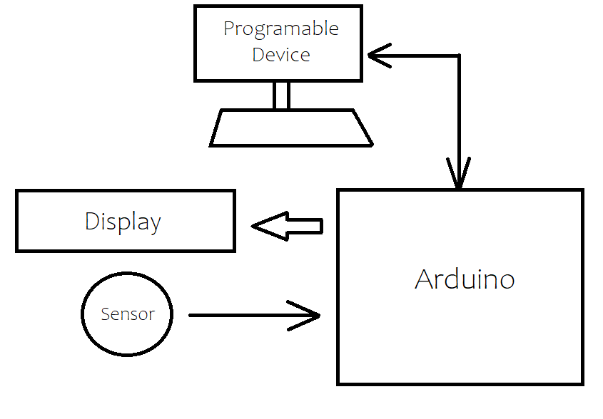

Fig: 1

Here the figure 1 our project diagram and its description is given below

1. First it takes input from the user using Heart Pulse Sensor.
2. The sensor is connected to the arduino so the arduino will pass the sensor data to the software.
3. There will be a program to show this sensor data in display or serial monitor as Beats per Minute(BPM).
4. In this program the to detect whether the BPM is in target heart rate zone the monitor will first require the person age and Resting Heart Rate(RHR).
5. Then based on the RHR the calculation is -

* Max Heart rate (MHR) = 220-Age
* Lower Target Heart Rate = MHR*0.6+RHR
* Upper Target Heart Rate = MHR*0.8+RHR

1. So, below the range the fitness is low, in the range fitness is moderate and beyond the range the fitness is abnormal.

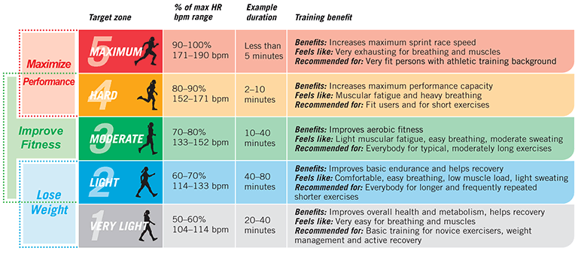

Fig: 2

Here in figure 2 explain that initially an athlete needs to do fitness testing workouts for required duration. During the workout period his heart beat rate will be monitored by our system.

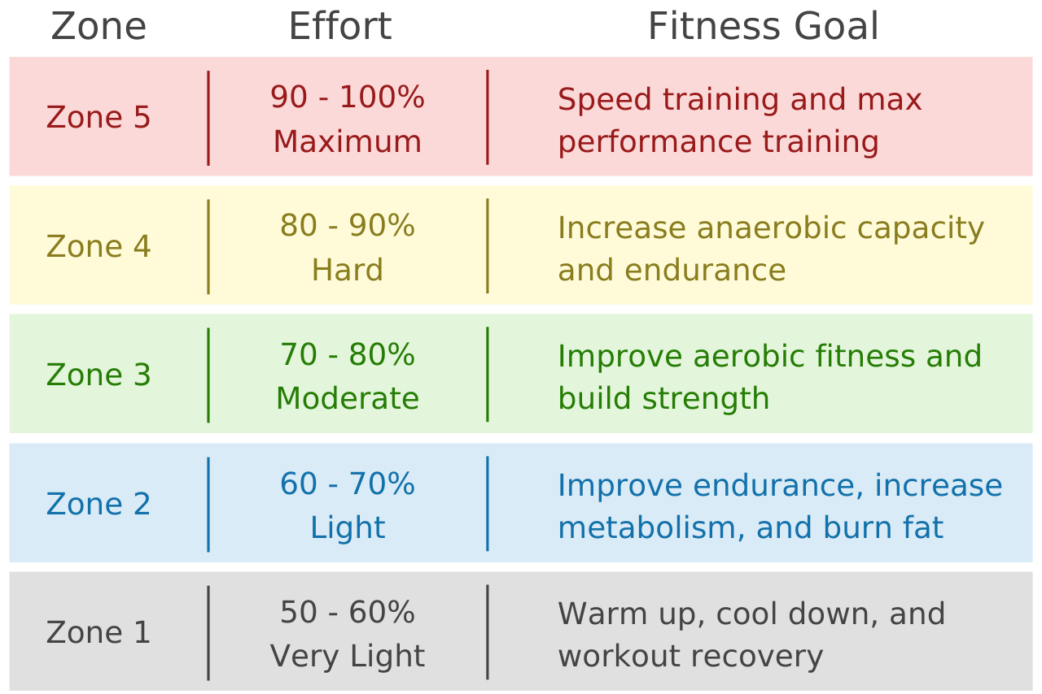

Fig: 3

Based on his heart rate the program will detect his fitness level according to the figure 3 chart.

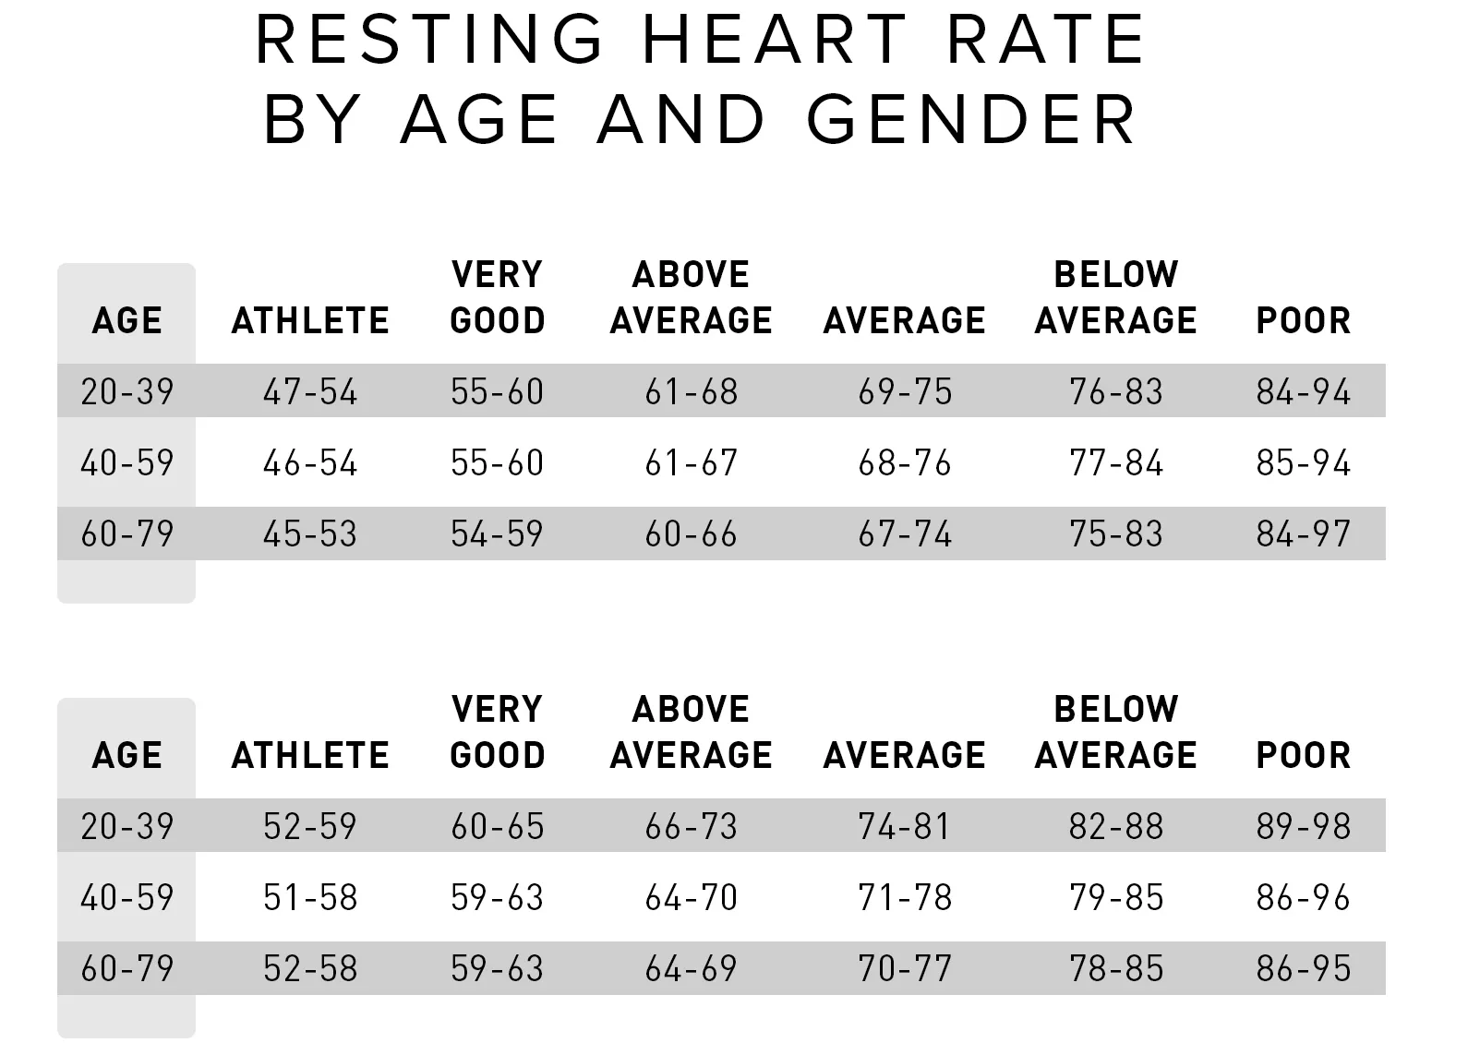

There will be required resting heart rate for which we have taken the scientific data.[25]

**VI.** TECHNICAL SPECIFICATION

| Name of component | Description |
| --- | --- |
| Breadboard | complicated wiring work could be a nightmare during the process of experiment[19]. |
| LCD 16*2 display | could be a flat board display, electronic visual screen, or video display unit, which utilizes daylight regulating liquid crystal property[20]. |
| IC2 display module | measure the consumer’s power consumption in KW-h and also enable and support consumption in rupees according to consumer tariff [21]. |
| Jumper wire | The jumper wires of an extra-high voltage (EHV) transmission line in strong-wind areas in Northwest China frequently break down[22]. |
| Heart pulse sensor  (SKU:SNO206) | is an electronic device that is used to measure the heart rate i.e. speed of the heartbeat[23]. |
| Arduino UNO | Arduino is an open-source platform used for building electronics projects[24]. |
| USB B cable | It is used to connect the arduino and code. The code we implement in the devices, can be used in Arduino through this. |

**V.** DESIGN AND IMPLEMENTATION

**Circuit Diagram:**

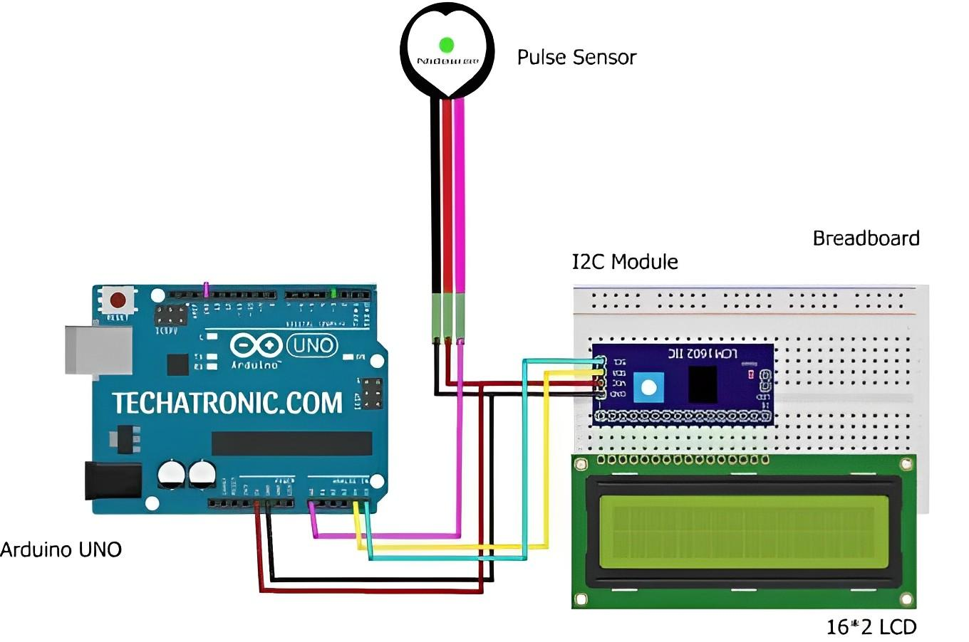

Steps of implementing the whole system are given below:

1. The ground of the i2c converter and arduino are connected
2. Now connect the vcc from the i2c controller with 5volt
3. Then convolt sda with pin a4 and scl with a5
4. Now we connect the i2c controller with the arduino board.
5. For the pulse sensor, there are 3 pins like signal, 5volt and ground. The 5volt pin connects with the arduino 5volt pin and the ground pin is connected with the GND of the arduino.
6. Now the signal pin is connected with the pin ao in the arduinproject
7. Then connect the arduino board with the laptop to do the software part.
8. The next step is to develop the code according to our output.

**This is the output of our project**

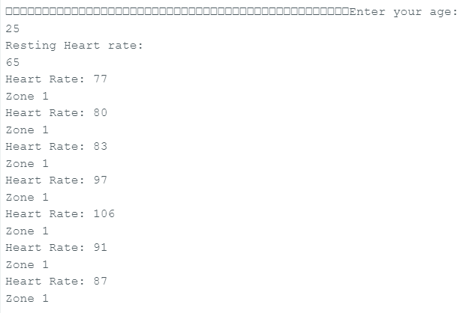

**Some pictures of our project are given below:**

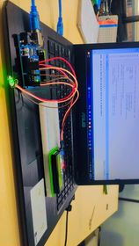

Coding Phase:

Step 1: Sensor = A0

Step 2: pulseSensor.analogInput(PulseWire)

Step 3: int myBPM = pulseSensor.getBeatsPerMinute()

Step 4: print"Enter your age: "

while (Serial.available() == 0)

Step 5: restingHR = Serial.parseInt()

Step 6: maxHR = 220 - age;

targetHRMin = (int)(0.5 * maxHR) + restingHR

targetHRMax = (int)(0.8 * maxHR) + restingHR

Step 7: if (heartRate > 0)

if (heartRate < targetHRMin)

print"You are not working hard enough."

else if (heartRate > targetHRMax)

print"You are working too hard."

else print"You are in your target heart rate zone."

**VI.** RESULT & ANALYSIS

| **List of exercises** | **Athlete 1** | **Athlete 2** | **Athlete 3** |
| --- | --- | --- | --- |
| **Bench Press(150sec)** | zone 3 | zone 4 | zone 2 |
| **Puss Up(120sec)** | zone 5 | zone 3 | zone 5 |
| **Front Squats(130sec)** | zone 2 | zone 5 | zone 1 |
| **Leg Press(160sec)** | zone 4 | zone 2 | zone 4 |
| **Box Jump(170sec)** | zone 5 | zone 1 | zone 3 |
| **Average Fitness Level** | Hard | Moderate | Moderate |

**VII.** USER FEEDBACK & FUTURE GOAL

| Features | Satisfied | Suggestion |
| --- | --- | --- |
| 1. Get to know the current heartbeat | 65% | Stable heartbeat |
| 2. Level of fitness | 70% | Get suggestion of exercise |

In the future, we want to add more input features related to body temperature, personal diseases, condition of heart and lungs in order to identify the fitness level of an athlete more accurately and suggest exercise based on the inputs. In addition, we also try to implement cloud data stores to observe one athlete's current condition more specifically and also make sure that the suggestions are appropriate for him.

**VIII.** CONCLUSION

Finally we find out that it is very important for a sportsman to identify which type of exercises actually suit him or her. So our fitness monitoring system helps them to enrich their potential and get maximum output in their athletics sector. Though initially we just work with only heartbeat but we want to carry our work and add more features. So lastly we can say that the possibilities of athletes facing injuries during any kind of practice can be minimized if the athletes test their fitness level by using our system.

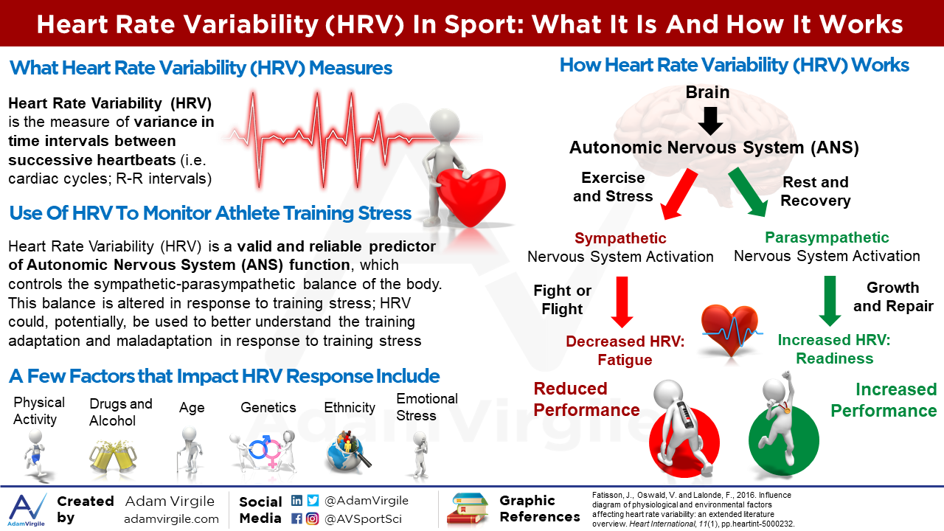

**IX. REFERENCES**

1. Yongjian Qiu. “Fitness Monitoring System Based on Internet of Things and Big Data Analysis.” *IEEE Access*, vol. 56, 2021, p. 12.

2.Pawan Singh. “INTERNET OF THINGS BASED HEALTH MONITORING SYSTEM : OPPORTUNITIES AND CHALLENGES.” *International Journal of Advanced Research in Computer Science*, vol. 9, no. 1, 2018.

3. Aditya Sharma. “Smart Health Monitoring System using IoT.” *International Journal for Research in Applied Science & Engineering Technology (IJRASET)*, vol. 45, 2020.

4.Jose Toledo Monsalve. “Design Flow of Wearable Internet of Things (IoT) Smart Workout Tracking System.” *IEEE*, 2019.

5. Robyn Braun-Trocchio. “The Effects of Heart Rate Monitoring on Ratings of Perceived Exertion and Attention Allocation in Individuals of Varying Fitness Levels.” *ORIGINAL RESEARCH article Front. Sports Act. Living*, vol. 3, 2022.

6. Binbin Yong. “IoT-based intelligent fitness system.” *Journal of Parallel and Distributed Computing*, vol. 118, 2018, pp. 14-21.

7. Harshvardhan K. “HEART RATE MONITORING SYSTEM USING IOT.” *International Research Journal of Engineering and Technology (IRJET)*, vol. 09, no. 1, 2022.

8. Stefan Altmann. “Using submaximal exercise heart rate for monitoring cardiorespiratory fitness changes in professional soccer players: A replication study.” *Sports Physiology And Performance*. *2020*.

9. Mohammad Monirujjaman Khan, Turki M. Alanazi, Amani Abdulrahman Albraikan, Faris A. Almalki, "IoT-Based Health Monitoring System Development and Analysis", *Security and Communication Networks*, vol. 2022, Article ID 9639195, 11 pages, 2022. https://doi.org/10.1155/2022/9639195

10. Christoph Schneider. “Heart Rate Monitoring in Team Sports—A Conceptual Framework for Contextualizing Heart Rate Measures for Training and Recovery Prescription.” *TECHNOLOGY REPORT article*, vol. 9, 2018.

11. Athlete's Heart and Cardiovascular Care of the Athlete. “Athlete's Heart and Cardiovascular Care of the Athlete.” *Scientific and Clinical Update*, vol. 123, 2011.

12. Gabriele Mascherini. “Normative values for heart rate response to exercise in young athletes at 10–18 years old.” *European Journal of Sport Science*, 2022.

13.[An Intelligent Sensor Based System for Real Time Heart Rate Monitoring (HRM)](https://www.scirp.org/journal/paperinforcitation.aspx?paperid=66790)"

written by *Nusrat Jahan Farin, S. M. A. Sharif, Iftekharul Mobin*, published by *Intelligent Control and Automation*, *Vol.7 No.2, 2016*

14. KuoTu Zhao, WeiJun Liu, "The Design of the Exercise Load Monitoring System Based on Internet of Things", *Wireless Communications and Mobile Computing*, vol. 2022, Article ID 8011124, 11 pages, 2022. <https://doi.org/10.1155/2022/8011124>

15. Subhashis Biswas. “A Study on Resting Heart Rate and Heart Rate Variability of Athletes, Non-athletes and Cricketers.” *American Journal of Sports Science*, vol. 8, 2011.

16. Nelson, M.J., Bellenger, C.R., Thomson, R.L. *et al.* Optimisation of assessment of maximal rate of heart rate increase for tracking training-induced changes in endurance exercise performance. *Sci Rep* 10, 2528 (2020). <https://doi.org/10.1038/s41598-020-59369-6>

17. Sumali B, Mitsukura Y, Nishimura T (2022) Contactless continuous heart rate monitoring system using ballistocardiography. PLoS ONE 17(7): e0272072. https://doi.org/10.1371/journal.pone.0272072

18. Michael S. Lauer,. “Impaired Heart Rate Response to Graded Exercise.” *Prognostic Implications of Chronotropic Incompetence in the Framingham Heart Study*, vol. 93, 1996, p. 8.

19. Run, Ray-Shine & Chang, Jun-He & Yen, Ming-Chi. (2016). The Wire-free Breadboard - A Feasibility Study on Digital Circuit. Universal Journal of Electrical and Electronic Engineering. 4. 97-103. 10.13189/ujeee.2016.040401.

20. Joshi, Tanuj & Sharma, Ravikant & Mittal, Vinod & Gupta, Vikas & Parkash, Om. (2020). Fabrication of Hybrid Bicycle for Minimizing Pollutant Emissions. Journal of Physics: Conference Series. 1478. 012036. 10.1088/1742-6596/1478/1/012036.

21. Shrestha, Sashank & Tamang, Adip & Belbase, Sandesh. (2021). ToD METER.

22. He, Kate & Han, Sang & Li, Zhenwang & Xiao,. (2019). Research on Failure Mechanisms of Broken Strands of Jumper Wires for EHV Transmission Lines in Strong-Wind Areas. Metals. 10. 39. 10.3390/met10010039.

23. Prakash, Ved & pandey, manoj. (2018). HEART RATE MONITORING SYSTEM.

24. Y. A. Badamasi, "The working principle of an Arduino," *2014 11th International Conference on Electronics, Computer and Computation (ICECCO)*, Abuja, Nigeria, 2014, pp. 1-4, doi: 10.1109/ICECCO.2014.6997578.

25. Avram R, Tison GH, Aschbacher K, Kuhar P, Vittinghoff E, Butzner M, Runge R, Wu N, Pletcher MJ, Marcus GM, Olgin J. Real-world heart rate norms in the Health eHeart study. NPJ Digit Med. 2019 Jun 25;2:58. doi: 10.1038/s41746-019-0134-9. PMID: 31304404; PMCID: PMC6592896.

**BIOGRAPHIES OF AUTHORS**

**Md. Arif Fuad Akash** completed higher secondary in 2018 and after that was admitted to Undergraduate in University of Liberal Arts Bangladesh in the 2020 spring semester. He is currently studying Computer Science and Engineering in the 8th term. He actively participated in many co-curricular activities, especially in Programming Contests. He is currently working in Data analysis and Machine Learning.



**Md. Mizanur Rahman** has been graduating from University of Liberal Arts Bangladesh since 2020. He has completed his Higher Secondary in 2019. Have a great attraction for doing social works, programming contests, machine learning and research related works. He is very determined to be updated regularly.



**Morium Begum** completed her Higher Secondary in 2019 and then she got admission in University of Liberal Arts Bangladesh (ULAB) in the department of CSE. She is currently in 10th semester and she is highly interested in extracurricular activities as well as programming contests.

In recent years, she is engaged with social related works and also taking initiatives to make her career in Machine Learning platform.